**Configure SSL VPN on Linux**

**INDEX**

1. How to install
2. How to connect Sophos VPN
3. How to connect remote pc by using Remmina

1.How to install?

Open terminal in Linux and type the below command

Sudo install openvpn

It will download and install

-Open <https://publicIP:8443> (Sophos Client) using any browser.

-Enter your domain login credentials (e.g. mm123 and your domain login password) > Click on **login**.

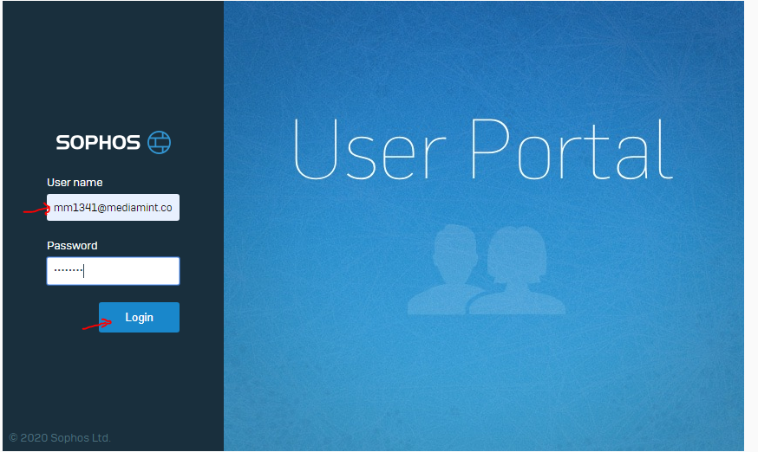

Download the VPN application

Once the open vpn installation is done.

Goto the download path where the file has been downloaded.

Now connect to VPN by entering below command.

sudo openvpn --config mmid123__ssl_vpn_config.com

It will ask credentials- Enter your system credentials

Enter user name:

Enter password along with OTP(received the OTP in Sophos intercept X mobile app)

After entering the credentials it will connect to Sophos VPN.

Now let us see how to connect to remote pc by using remmina.

Remmina is a default remote application in linux(Ubuntu).

Enter the below command to start the RDP services up and running

sudo systemctl enable --now xrdp

enable means - whenever we restart the system the RDP services are up and running.

Below is the screenshot for remmina remote desktop client

server: enter remote pc ip address

username: enter remote pc username

password: enter remote pc password

Click on connect. It will connect

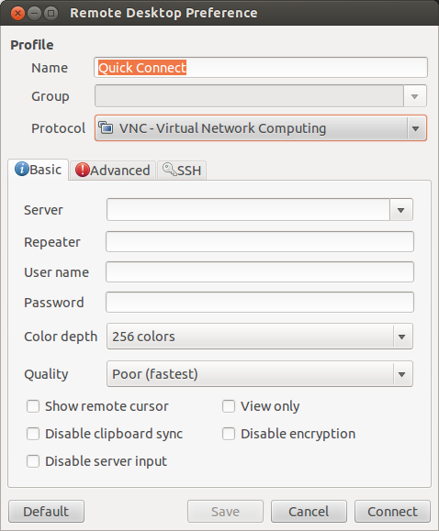

*** THE END ***